.lppppppppppppppp



31 October 2018.

Citizen - Politician System

By: 101358, 102008.

An informatics system project final system documentation submitted to the faculty of information technology in partial fulfilment of the requirements of the award of a degree in Informatics and Computer Science.

# Declaration

We, 101538 and 102008, declare that this project has not been submitted in Strathmore University or any other university for the award of a degree in Informatics and Computer Science or any other degree.

**Student Signature:**

Sign ­­­­­­­____________________________ Date __________________

**Student Signature:**

Sign ­­­­­­­____________________________ Date __________________

**Supervisor Signature:**

Sign ­­­­­­­____________________________ Date __________________

# Abstract

The status quo in Kenya is that citizens do not know the type of leader they select. In most cases citizens often find that the leader disappears after he is elected. The elected leaders also do not fulfil their duties as stipulated in the constitution or their manifesto.

Normally during elections, candidates hand out their manifestos in form of booklets. In most situations some of the objectives in the manifestos are not fulfilled. Citizens have no way of contacting their leaders to raise a complaint or observation.

This document proposes a web application that displays information about a politician that is relevant to the public. With this application citizens can also contact the leader and also post problems related to the respected area. Citizens will also be able to see a detailed analysis of their leaders to help them decide who to vote for.

The type of system development methodology being used is prototyping. This type of methodology best fits the proposed system since it is easier to test and develop. Also, the users are constantly met to refine their requirement specifications thus developing a system that best fits their needs. The prototype will eventually become the final product (Evolutionary Prototyping).

# Table of Contents

Declaration ii

Abstract iii

Table of Contents iv

List of Figures vi

List of Tables viii

Chapter 1: Introduction 1

1.1 Background 1

1.2 Problem Statement 2

1.3 Aim 3

1.3.1 Specific Objectives 3

1.3.2 Research Questions 3

1.4 Justification 3

1.5 Scope and Limitation 4

Chapter 2: Literature Review 5

2.1 Introduction 5

2.2 Challenges Facing Kenyan Citizens in the Political Process 5

2.3 Existing Platforms for Evaluating Politicians 5

2.3.1 I-Citizen 5

2.3.2 PolitiFact 7

2.3.3 African Politics and Policy (APP) 8

2.4 Gaps in Existing System 9

Chapter 3: Methodology 10

3.1 Introduction 10

3.2 System Development Methodology 10

3.2.1 Requirements gathering and analysis: 11

3.2.2 Quick Design: 11

3.2.3 Build Prototype: 11

3.2.4 User evaluation: 12

3.2.5 Refining prototype: 12

3.2.6 Engineer product: 12

3.3 Deliverables 12

3.3.1 Admin Module 12

3.3.2 Politician’s Module 12

3.3.3 Citizen’s Module 13

3.4 System Development Tools and Techniques 13

3.4.1 Web Design Tools 13

3.4.2 Back End Development Tools 14

3.4.3 Database Tools 14

3.4.4 Software Tools 14

3.4.5 Online Resources 14

Chapter 4: System Analysis and Design 15

4.1 Introduction 15

4.2 System Analysis 15

4.2.1 Functional Requirements. 15

4.2.2 Non-Functional Requirements 15

4.3 System Narrative 16

4.4 Design Diagrams 17

4.4.1 Use Case Diagram 17

4.4.2 Data Flow Diagram (DFD) 18

4.4.3 Entity Relationship Diagram (ERD) 19

4.4.4 Database Schema 20

Chapter 5: System Implementation and testing 24

5.1 Introduction 24

5.2 Admin Module 24

5.2.1 Functionalities 24

5.2.2 Screenshots 24

5.3 Politician Module 24

5.3.1 Functionalities 24

5.3.2 Screenshots 24

5.4 Citizen Module 24

5.4.1 Functionalities 24

5.4.2 Screenshots 24

References 25

Appendix 27

Appendix A: Gantt Chart 27

# List of Figures

Figure 2.1: Citizen Interests 5

Figure 2.2: New Ideas 6

Figure 2.3: Polls 6

Figure 2.4: Popular leaders 7

Figure 2.5: Politician Rankings 8

Figure 2.6: APP Home 8

Figure 2.7: African Politics and Policy 9

Figure 3.1: Steps in Prototyping methodology (Naumann & Jenkins, 1982). 11

Figure 3.2: Use Case Diagram 15

Figure 3.3: Data Flow Diagram 16

Figure 3.4: Entity Relationship Diagram 17

Figure 5.1: Gantt Chart Table 25

Figure 5.2: Gantt Chart Diagram. 25

# List of Tables

Table 3.1: Politician Political Profile 17

Table 3.2: Politician Achievements and Critiques. 18

Table 3.3: Politician Educational Background 18

Table 3.4: Bugs and Reports. 18

Table 3.5: Politician Comments. 19

Table 3.6: Politician Personal Profile. 19

Table 3.7: Admin Profiles. 19

Table 3.8: Citizen Profiles. 20

# Chapter 1: Introduction

## 1.1 Background

The law of Kenya embodied in the Kenyan Constitution gives qualifications for various political seats from the lowest to the highest (Kramon & Posner, 2011). The Constitution of Kenya 2010 gives more viable and better qualifications than the Independence Constitution. For example, the former considers the educational background of our leaders, stating that a leader must at least have a degree if they wish to sit in office (Kramon & Posner, 2011). In the past anyone could get into office.(*Joho*, 2017). Leaders currently present their papers to the Electoral Committee, but citizens do not get to know what is on them, especially for low level leaders.

The Kenyan constitution was promulgated on the 27th of August 2010 (Kramon & Posner, 2011), leading to a devolved government and independence of the arms of government. Not everyone really understands the work of the various leaders in the devolved government (Cheeseman, Lynch, & Willis, 2016). People tell leaders in their region problems that do not fall in their docket. The roles of different leaders are not understood by many people. The people with the highest number of votes live in oblivion and though our leaders have tried, they have not succeeded in fully educating them.

Leaders in Kenya get into office through elections after every five years (Kramon & Posner, 2011). They can go for re-election for another term. The constitution states that a leader can only be in office for a maximum of 2 5-year terms years (Kramon & Posner, 2011). During campaigns the candidates move to the streets giving out their manifestos in form of booklets for all to read. Voting takes place but many of the successful leaders do not manage to achieve what they promised to achieve through their manifesto. Citizens also do not have the means to either air their views on their leaders’ contribution to development or to know what the leaders have achieved in relation to their manifesto. In other words, citizens do not have a forum where they can view what their leaders have done in their terms of office, air their views on what those leaders have done with respect to what was expected of them and get a comparison on if they fulfilled their duties efficiently. Efficiency here means that the leader followed both their manifesto and the constitution in carrying out their duties.

The country has a tense voting period due to the 2007/08 post-election violence. (Ismail & Deane, 2008). People from the outside community normally come into the country after that event to supervise our elections. Kenyans try to lighten the tension with funny memes. What really happened in 2007? Leaders sent out their people to spread propaganda about their counterparts. (Ismail & Deane, 2008). This lead to a tense atmosphere in the country and resulted in the post-election violence. This left many citizens displaced as Internally Displaced Persons, businesses shut down and the foreign sector suffered a major blow (Ismail & Deane, 2008). It is common to hear people saying they will vote for a leader who is of the same tribe. This is because after what happened in 2007/08, Kenyans cannot trust anyone who does not speak their language (Ismail & Deane, 2008). Kenyans need a source of political information that is free from bias and propaganda to prevent the events of 2007/08 from re-occurring.

After elections citizens depend on social media to contact their leaders. Leaders normally have social media accounts where they post information and citizens can react to this information. They also go directly to the leader’s office, but they may lack an appointment or must travel very far to meet them, especially those of higher ranks. Most of the information in social media is not free from bias neither is it credible. Corruption is a norm in Kenya (K. R. Hope, 2017). Kenyans voted in a leader whose integrity was questionable (Kamau, 2018). The Bible says that God’s people perish due to lack of knowledge. And the lawyers have their motto: Ignorance is no defense. From that aspect all this would not have happened if the people had information about the leaders to begin with.

Information is needed to bring change in Kenya. A technological approach is the best way to solve the problem at hand.

## 1.2 Problem Statement

Normally, during campaigns politicians present their manifestos to the citizens to gain more votes on their side. The constitution and the manifesto are not used to gauge the efficiency of the leader after his term of office.

For low level positions like MCA, most of the time citizens have no idea who the person is, what he does or what he stands for. This is quite a critical issue because what happens during elections is that the citizens choose a leader who is in their favourite political party hence they choose a person they don’t know and thus there is a high likelihood that the politician will sit on his job.

After elections once the leader has been chosen, usually the politician sets up an office where the citizens can reach to him and inform him of any problems. At times the location is too far for the citizens to access and since some do not have adequate means to communicate with the politician it becomes hard to contact the politician.

Citizens often follow euphoria in voting instead of analysing achievements of the campaigner in their area. This is an issue that brings about biasness for example, especially in the rural areas the citizens choose a person who belongs to their tribe even if he is not the qualified person for the position. Citizens need to be made aware of the qualification status of their leaders.

Citizens do not get to know what to know what their politicians have done in their terms of office. This brings about confusion during re-election since some don’t know what the politician has done for his people. It may lead to the election of a lazy leader and ruling out of a good potential leader.

## 1.3 Aim

To develop an application that assists the citizens to know their politician fully and his efficiency in bringing change to the country.

### 1.3.1 Specific Objectives

1. To investigate challenges the challenges face by citizens during the election process.
2. To review existing solutions that will enable citizens of a country to know about their politicians and post their opinions about the leaders.
3. To design, develop and test an application that assists the citizens to know their politician and his efficiency in bringing change to the country.

### 1.3.2 Research Questions

1. What are the challenges faced by citizens during the political process?
2. What are the existing solutions?
3. How is a political application designed, developed and tested to assist citizens know their politician?

## 1.4 Justification

The system bridges the gap between the citizen and the politician and enables citizens to see an evaluation of their politician on an unbiased platform. This will enable the citizen to make an informed decision come the following elections about who to vote for. It will also enable the citizen to know their politician better and get contact information to contact them in case of anything. Finally, it is important for the citizen to be able to participate in the political process by posting comments about their leaders so that they may know what to do.

## 1.5 Scope and Limitation

Kenya is divided into 47 counties, leaders are allocated according to this system, but this system will cover only 10 counties and with the respective leaders. These are Kiambu, Nairobi, Machakos, Meru, Mombasa, Nyeri, Homa Bay, Kirinyaga, Kisii, Murang’a. This is because of time constraints thus it will be hard to get information about leaders from all counties. The scope will also involve only electoral seats of the government: Member of parliament (MP), Governor, Women Representatives, Senator, Members of county assembly (MCA).

Limitations: The leaders may give false information about their personal or educational background. The leaders may decide to be discrete about their information. To cover all the 47 counties requires a lot of attention and time may be a limiting factor. The platform is admin dependent, so the integrity of the administrators must be unquestionable which is hard to establish. Politicians may fail to create accounts on the website which will lead to an inefficient website. Citizens may also fail to create accounts which will reduce the user base thus leading to an inefficient system. The system also needs internet to be access.

# Chapter 2: Literature Review

## 2.1 Introduction

This chapter discusses the challenges encountered by the citizens during and after elections. It also shows the existing platforms and websites like ours and an evaluation of those platforms. This chapter finally highlights the gaps in the existing systems.

## 2.2 Challenges Facing Kenyan Citizens in the Political Process

During elections, the citizens do not have enough information about particular candidates rendering confusion and election of corrupt leaders. The elected politicians don’t do their respective jobs. The elected politicians lie about what they have done for citizens. The citizens cannot easily contact their leaders in case of a problem. The elected politicians do not follow their manifesto when working for the citizens. New and upcoming leaders have no platform to forecast their ideas to the public.

## 2.3 Existing platforms for evaluating politicians

There are 3 websites similar to ours and we evaluated them as follows:

### 2.3.1 I-Citizen

I-citizen is a web application that enables users to vote in polls on trending issues. Elected officials can gauge public opinion to make informed decisions. Leaders can test new ideas to a targeted audience. It is source for local, state and national news. Track trending polls and issues in your community (“Polling and Data Analytics,” 2016).

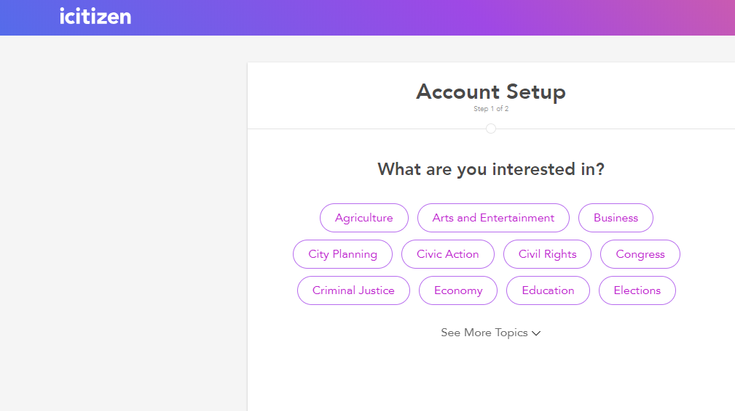

#### Figure 2.1: Citizen Interests

Here users select particular topics of interests in order to get news based on their interests. This helps shape their notifications based on what they like.

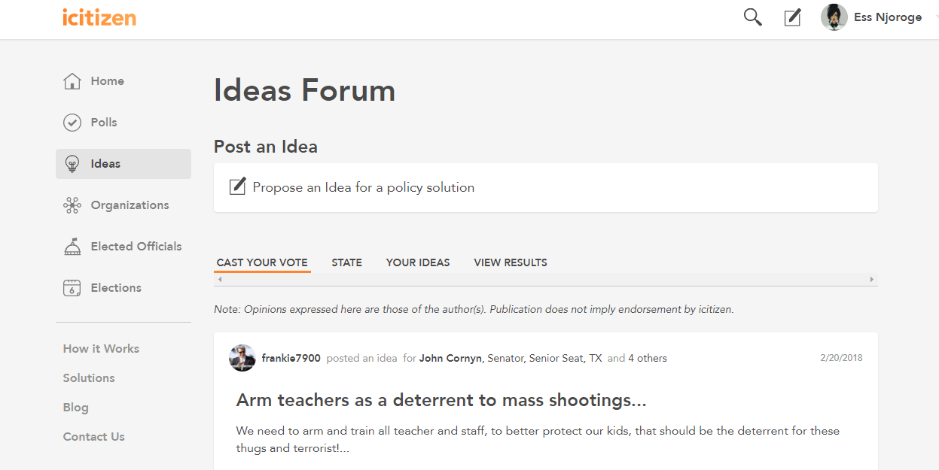

#### Figure 2.2: New Ideas

Users can post a new idea which will be seen by other viewers and also by politicians thus enabling the politicians to implement ideas directly from their citizens.

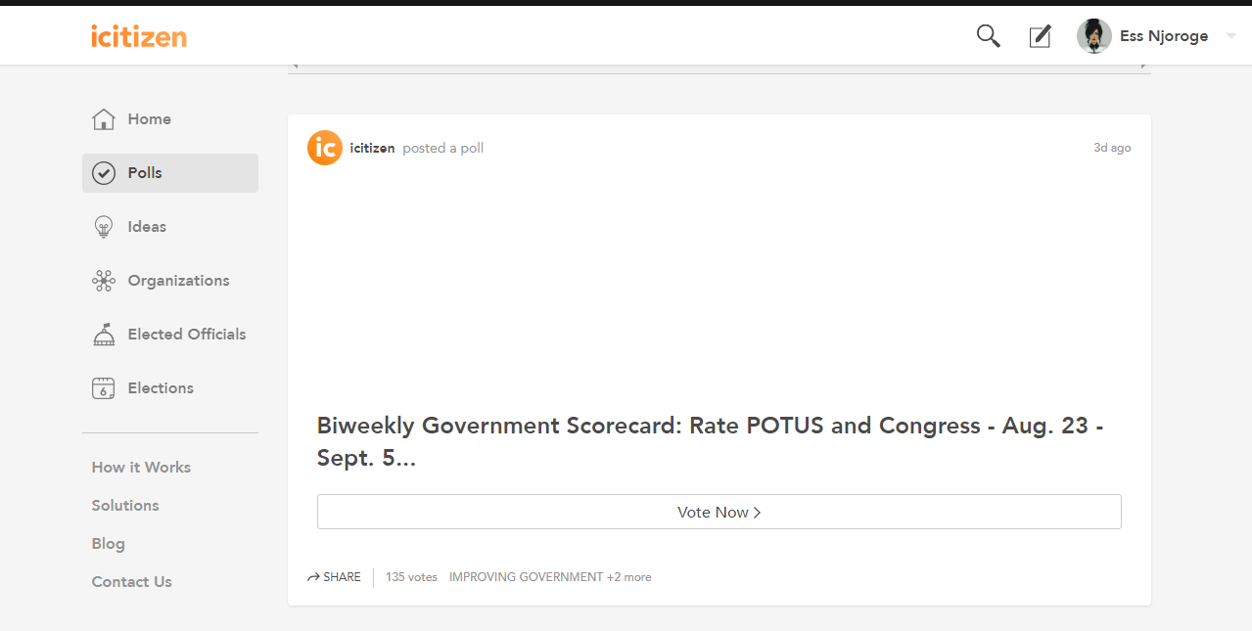

#### Figure 2.3: Polls

Checking polls. Here users can check polls of different subjects of interest.

### 2.3.2 PolitiFact

PolitiFact is focused on looking at specific statements made by politicians and rating them for accuracy. PolitiFact is run by the editors and journalists who make up the PolitiFact team (“Fact-checking U.S. politics,” 2005).

The goal of the Truth-O-Meter is to reflect the relative accuracy of a statement. The meter has six ratings, in decreasing level of truthfulness: TRUE – The statement is accurate and there’s nothing significant missing. MOSTLY TRUE – The statement is accurate but needs clarification or additional information. HALF TRUE – The statement is partially accurate but leaves out important details or takes things out of context. MOSTLY FALSE – The statement contains an element of truth but ignores critical facts that would give a different impression. FALSE – The statement is not accurate. PANTS ON FIRE – The statement is not accurate and makes a ridiculous claim (“Fact-checking U.S. politics,” 2005). The burden of proof is on the speaker, and then statements are rated based on the information known at the time the statement is made.

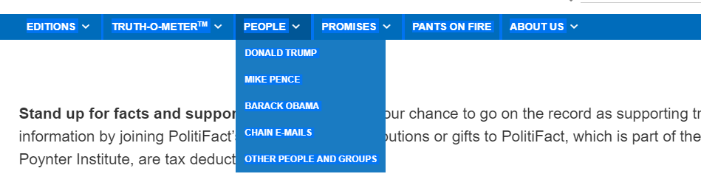

#### Figure 2.4: Popular leaders

There are only a few leaders which this application focuses on. These are the popular leaders in the area.

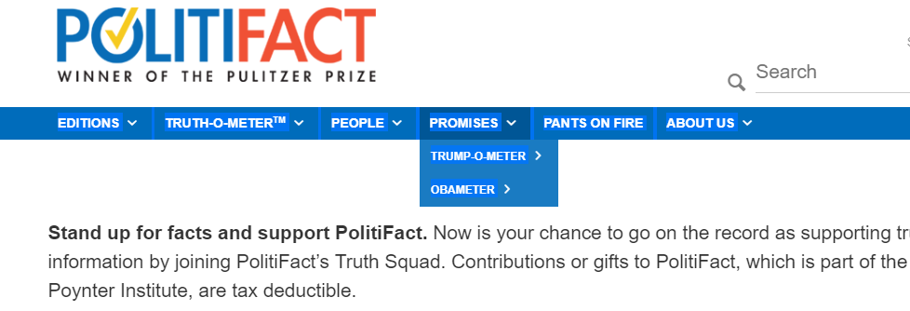

#### Figure 2.5: Politician Rankings

Promises the leaders stated. The site keeps track of what the leaders have promised their citizens. This helps politicians keep their promises since they know it might be used against them.

### 2.3.3 African Politics and Policy (APP)

This website displays latest political stories happening in Africa. Keeps Africans informed about what is going on (“African Politics and Policy Newsletter,” 2010). In its description, it is described as an online journal.

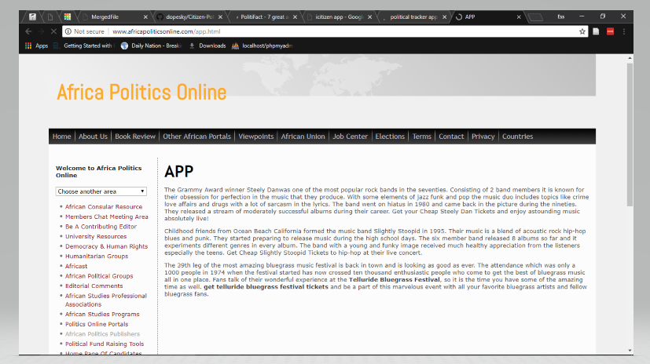

#### Figure 2.6: APP Home

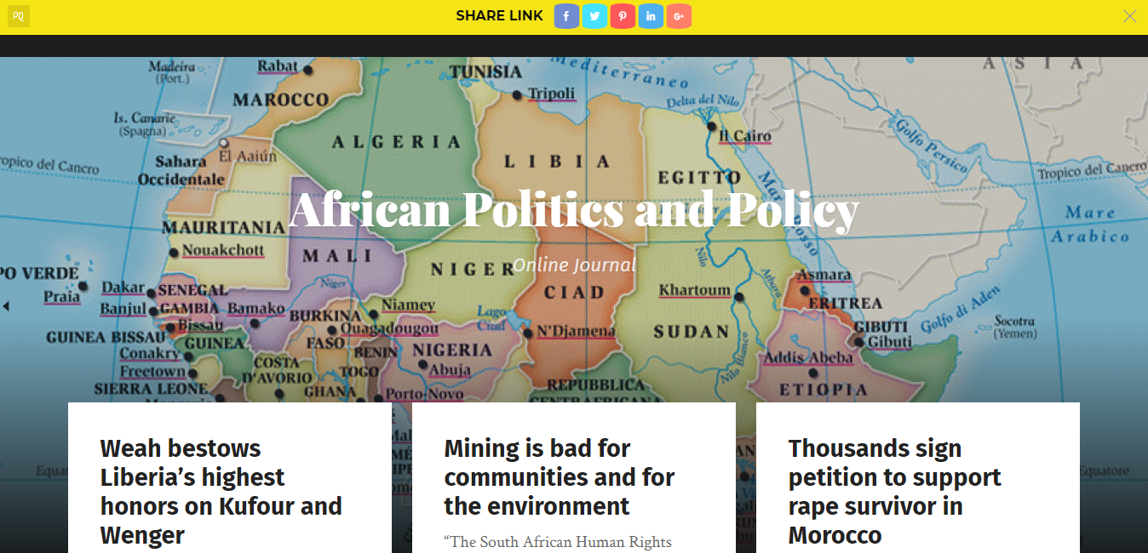

#### Figure 2.7: African Politics and Policy(“African Politics and Policy Newsletter,” 2010)

## 2.4 Gaps in Existing System

The above applications only give information about what is happening in politics. They do not have information about politicians in terms of their background information. They also do not provide contact information of the politicians. Finally, the most obvious gap is that the sites have scope limited to the United States or Africa in general thus there is need to have one that is tailored for Kenya.

# Chapter 3: Methodology

## 3.1 Introduction

This chapter discusses the System Development Methodology, System Analysis and Design aspect of the project, System Development Tools and Techniques and the Deliverables for the project.

## 3.2 System Development Methodology

A Software Development Methodology or System Development Methodology in Software Engineering is a framework that is used to structure, plan, and control the process of developing an information system (“Software Development Methodologies,” 2016).

The Citizen - Politician Website will be developed using the Prototyping Model. The Prototyping Model is a Software Development Life Cycle Model where a prototype is first developed to allow the users to evaluate developer proposals and try them out before implementation (Naumann & Jenkins, 1982). A prototype is a working model of the proposed system.(Naumann & Jenkins, 1982)

The prototyping model to be used will be the Evolutionary Prototyping model. The Evolutionary Prototype model is a life cycle model in which the system is developed in increments so that it can readily be modified in response to end user and customer feedback (Shafer, Press, Scott, & Bieman, n.d.). This means that the prototype eventually becomes the final product. Prototyping consists of 6 stages:

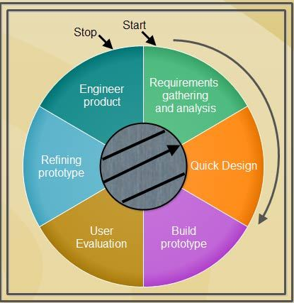

#### Figure 3.1: Steps in Prototyping methodology (Naumann & Jenkins, 1982).

### 3.2.1 Requirements gathering and analysis:

  A prototyping model begins with requirements analysis and the requirements of the system are defined in detail. The user is interviewed to know the requirements of the system. Basic system requirements for the Citizen – Politician Website as described on the System Objectives. These were arrived at from Interviews with the citizens, politicians and owners of the system who will act as the administrators of the system.

### 3.2.2 Quick design:

When requirements are known, a preliminary design or quick design for the system will be created. It will not be a detailed design and will include only the important aspects of the system, which gives an idea of the system to the user. A quick design helps in developing the prototype.

### 3.2.3 Build prototype:

Information gathered from quick design is modified to form the first prototype, which represents the working model of the required system. The first prototype of the project website will be presented to users for verification and then comments from users will be used to modify the system.

### 3.2.4 User evaluation:

Next, the proposed system will be presented to the user for thorough evaluation of the prototype to recognize its strengths and weaknesses such as what is to be added or removed. Comments and suggestions will be collected from the users and provided to the developer.

### 3.2.5 Refining prototype:

Once the user evaluates the prototype and if he is not satisfied, the current prototype will be refined according to the requirements. That is, a new prototype is developed with the additional information provided by the user. The new prototype will be evaluated just like the previous prototype. This process continues until all the requirements specified by the user are met. Once the user is satisfied with the developed prototype, a final system is developed based on the final prototype.

### 3.2.6 Engineer product:

  Once the requirements are completely met, the user accepts the final prototype. The final system will be evaluated and tested thoroughly followed by the routine maintenance on regular basis for preventing large-scale failures and minimizing downtime.

## 3.3 Deliverables

There shall be 3 deliverables for this project: Citizen’s Module, Politician’s Module and an Admin Module.

### 3.3.1 Admin Module

The admin module will only be used for verification purposes. It will verify Politician accounts in the system, comments by users, any post that comes into the system from the users and it will also specify the dates for the next election. The admin module will also be responsible for defining functions of various governmental seats so that these functions can be used to gauge the efficiency of the politicians. No post or comment will be visible to users unless verified by the admin module. No Politician account will be viable unless verified by the admin module. Admins will also be allowed to remove accounts that do not agree with terms and conditions of the site, view and reply to bug reports and respond to problems brought to light by the users.

### 3.3.2 Politician’s Module

The Politician’s module will allow politicians to create accounts and specify their background, personal and political information. This information will be visible to all after verification. Users can then post their own information regarding the politicians in terms of achievements, critiques and comments. Both the posted information and the information provided by the politician himself will be used to gauge the popularity and performance of the politician in his seat. This module will also allow politicians to post achievements and critiques about themselves or other politicians but not comments to prevent spreading of propaganda. Politicians will also be allowed to specify if they will be participating in the next elections. This module will finally be able to allow a politician to post their manifesto or alter their information. A manifesto can only be posted once in a term of office before elections are held.

### 3.3.3 Citizen’s Module

The Citizen’s module will allow citizens in general to create accounts. A politician cannot have a citizen account. Citizen accounts will allow users to view politician information and post comments about the politicians. They will also be able to post politician achievements and critiques on this module. All information posted by this module will need verification by admin module before it become viable. A citizen account will also need to be verified by an admin to ensure it is not a politician disguised as a citizen. Also, it will need to be ascertained that the citizen does not own more than one account in the System. This account will be the main source of information about politicians. This is because the politicians are working for the citizens and citizens need to verify that the politicians are really doing their jobs.

## 3.4 System Development Tools and Techniques

This refers to the actual tools used in develop the website. The tools to be used will be grouped into 5: Web design tools, back-end development tools, database tools, software tools and online resources.

### 3.4.1 Web Design Tools

The web design tools to create web pages will be Hypertext Mark-up Language (HTML), Cascading Stylesheets (CSS) and JavaScript (Ajax and jQuery). Hypertext Mark-up Language (HTML) will be used to define the logical representation of elements on the different web pages. Cascading Stylesheets (CSS) will be used to define format of the web pages and their elements. JavaScript will be used to create dynamic web pages with the help of Ajax and jQuery. Bootstrap will also be employed to create web pages that change depending on size of screen thus looking good on any device. These web design tools are essential for front end development of the web pages. This refers to the user interface and user experience.

### 3.4.2 Back End Development Tools

PHP will be the main backend language for the platform. PHP will help in processing of data to give information and will also enable communication with the database. A database is needed for storage of information. Java may also be employed in the backend if a functionality is better implemented in Java than PHP due to constraints like security. These two back end languages will enable data to be processed to give information that can be used in decision making.

### 3.4.3 Database Tools

The database will be a MySQL database which will be put on an online database for availability. A database is essential for information storage after processing on the back end. The MySQL database will first be designed and tested on localhost using Apache phpMyAdmin before being deployed to an online database vendor.

### 3.4.4 Software Tools

The software to be used in development will be Sublime Text for HTML, CSS, JavaScript (front end) and PHP (back end) and NetBeans for Java Servlets (back end). Apache (phpMyAdmin) will be used to develop the database on localhost after which it will be deployed. The website will also first be developed and tested on localhost through Apache servers before it is deployed. This is because PHP and Java Servlets code can only run on a server and Ajax has strict policies like same origin policy. Thus, to mitigate these constraints, the initial server will be localhost (Apache Xampp) before deployment.

### 3.4.5 Online Resources

These are the online platforms that will aid in development or research in this project. Information on coding will be retrieved from sites such as docs.Oracle, Php.net, StackOverflow and W3Schools. The project files will, after development and testing on localhost, be deployed on GitHub. This will enable it to be always available from any part of the world. GitHub will also be used for collaboration between us since it is a version control system, thus enabling ease of development. The database will be deployed on an online database vendor. These online resources will enable ease of development and deployment of the system after development and testing.

# Chapter 4: System Analysis and Design

## 4.1 Introduction

This chapter discusses the System Analysis and Design which includes examining out how the present system works.

## 4.2 System Requirement Analysis

System Requirement Analysis in software Engineering encompasses those tasks that go into determining the needs or conditions to meet for a new or altered product or project, taking account of the possibly conflicting [requirements](https://en.wikipedia.org/wiki/Requirement) of the various [stakeholders](https://en.wikipedia.org/wiki/Stakeholder_(corporate)), analysing, documenting, validating and managing software or system requirements.These requirements include: Functional and Non-functional Requirements.

## 4.2.1 Fundamental Requirements

These describe what the system should do so that the user can accomplish a specific task, in other words, the behaviour of the system.

Generally, the Citizen-Politician Website enables its users to create accounts, log into their accounts, define the type of account created either as a citizen or a politician. The citizen can post a comment, an achievement or a critique regarding a politician which then the system creates a percentage score in accordance with what the citizen posts. The system also enables citizens to search for posts for example a video or a comment.

The system shows recently posted stories happening in various counties, politician information and own account information. The politician is able to post a manifesto, participation in the next elections, post their personal, educational and political background and finally the politician can start a poll in which the citizens will contribute.

The administrator is able to verify or disable accounts, verify posts made by users, declares and update functions of politicians, update date of the next elections, reply to bugs posted by other users, perform site settings and reply to bugs posted by other users.

## 4.2.2 Non-Fundamental Requirement

These describe the quality attributes, design and implementation, constrain and external interfaces which the system must have.

Availability- The data is stored in a database which then together with the entire system is stored in an online trusted server.

Portability- The system is accessible to users using different platforms such as Windows, Linux provided the browser is available since the system is web-based.

Operational- The use of bootstrap has enabled the system to be available on any device either a mobile phone or desktop.

Reliability- Information is gathered from a trusted source which is then verified by the admin and the system is developed to be reliable in terms of information provided.

Usability- The system is user friendly such that it is easy to use and navigate.

Security-The accounts created and the database itself is secured using passwords.

Maintainability - The admin constantly performs system settings.

## 4.3 System Narrative

The first thing any user on the Citizen-Politician Website will glance at is the homepage. The homepage consists of a bit of information about the system and hyperlinks for registering I, login and navigation to other pages like report a bug page, request for help and Contact page. A user is allowed to login successfully creating an account in the system. The user is then redirected to the star page depending on the type of user he or she signed up as.

The Citizen-Politician Website will have a homepage. The homepage will be a page with a little bit of information about the system and hyperlinks for registering, login, and navigating to other pages like report a bug page, ask a question page or contact us page. A user will be allowed to login after successfully creating an account in the system. The user will then be redirected to the start page.

The start page will have recent stories and a navigation bar to navigate to other pages. One of the pages will be the politicians’ page. This page will allow the user to search or sort politicians and view their information. It will also allow a user to post information about a politician in terms of critiques, achievements and comments.

Another page will be my profile page which will have information about the current logged in user. There will also exist a settings page which will allow the user to select various settings like change profile details. Information available about the politician will be personal, political or educational.

There will also exist a page where users will be able to see various rankings of politicians vying for the same seat in the same or all counties in the upcoming elections. The rankings will be a percentage score of popularity to the citizens and viability/efficiency of the candidate to the seat they are taking.

The politician’s module will have the same interface as the citizen’s module only with a few major changes. Politicians will not be able to post comments, only achievements and critiques. They will also have a page that will guide them on how to post a manifesto. In their my profile page, politicians will also be able to specify if they will be participating in the next election and for what seat.

All information available on the site will either come from the citizen’s module or the politician’s module but will have to be verified for accuracy by the admin module.

## 4.4 Design Diagrams

## 4.4.1 Use Case

#### 

#### Figure 4.1: Use Case Diagram.

## 4.4.2 Data Flow Diagram

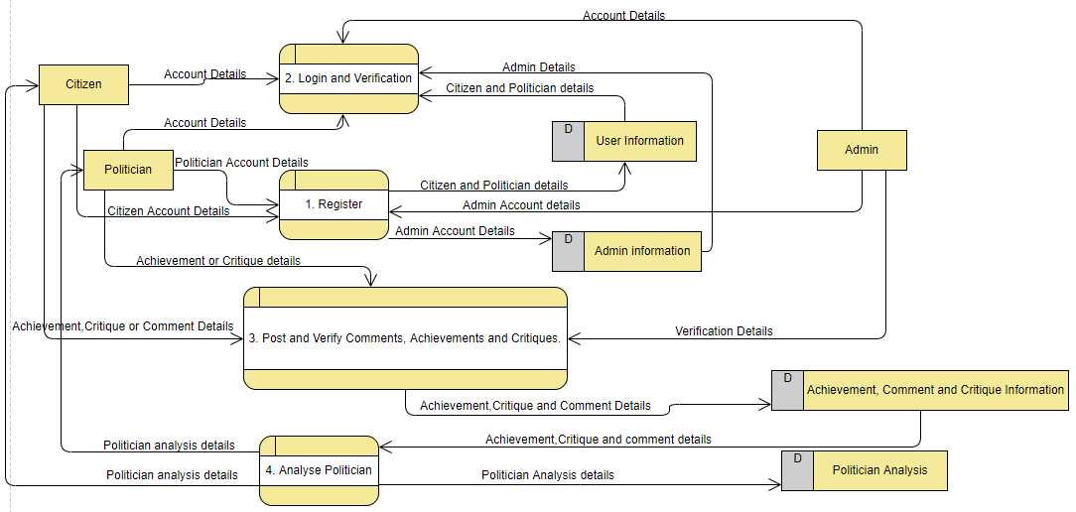

#### Figure 4.2: Data Flow Diagram

### 4.4.3: Entity Relationship Diagram

## 4.4.4 Database Schema

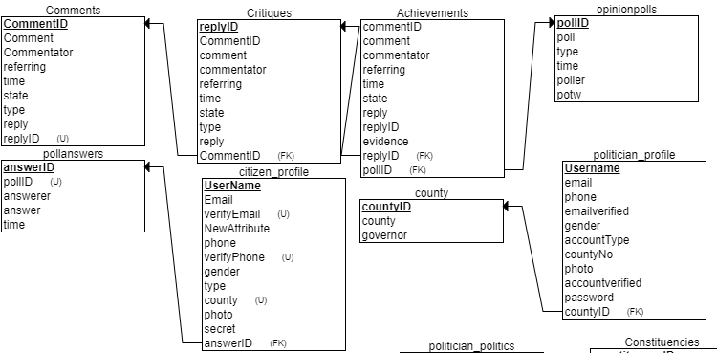

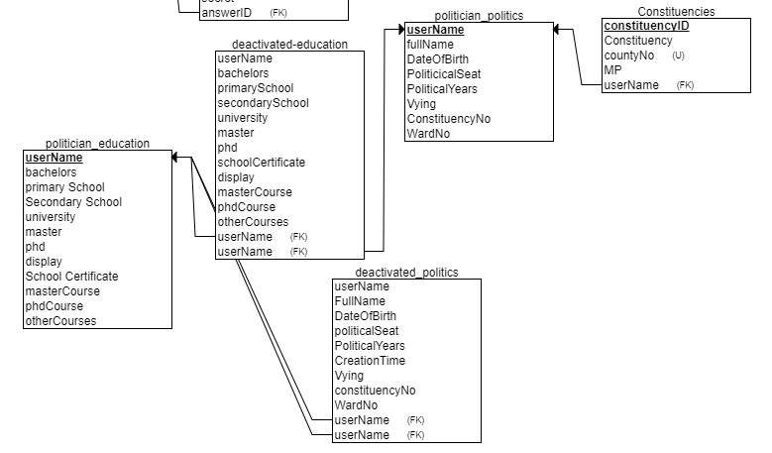

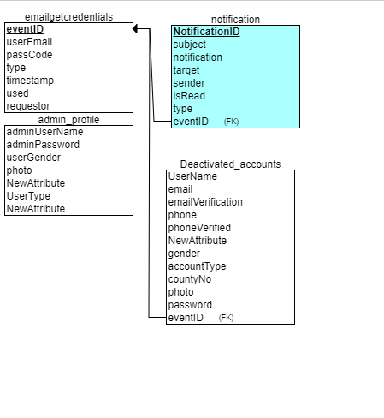

#### Figure 4.4: Database Schema.

# Chapter 5: System Implementation and testing

## 5.1 Introduction

This chapter describes Software Implementation and testing is an investigation conducted to provide stakeholders with information about the [quality](https://en.wikipedia.org/wiki/Software_quality) of the [software](https://en.wikipedia.org/wiki/Software) product or service under test. The goal is to see how the system works.

## 5.2 Admin Module

The admin module is used for verification purposes. It verifies the Politician, citizen and other Admin accounts in a way that accounts that do not agree with terms and conditions of the sites are removed. The admin ensures the comments, critiques and achievements posted are valid. The module is responsible for defining functions of various governmental seats so that these functions can be used to gauge the efficiency of the politicians. The admin also specifies the elections dates, views and replies to bug reports and responds to problems brought to light by the users.

The system requires consistent maintenance thus the admin performs system settings for example editing profiles. The admin also declares the roles of the politician. Finally, on the Politician side, the admin sends relevant emails and notifications.

### 5.2.1 Functionalities

The admin has various functionalities in our site. An admin’s main functionality is to be able to verify site data. First, he/she can verify politician accounts to ensure the data presented is true, up-to-date and referring to the politician who created the account. Politicians are not able to use their accounts until their data is verified by the admins. Admins also verify posts by all users to ensure they are not false and they are not aimed to cause discomfort to the people. Verified posts will have a verified mark on them. Furthermore, admins start opinion polls which can be answered by the users and the results given in real time. Admins set some important site data like the next election date, the official site email which appears at the login page and the leaders for the various areas in the country. Finally, admins can deactivate and reactivate user accounts if company policy is violated and they can also send notifications and emails to various users of the site.

### 5.2.2 Screenshots

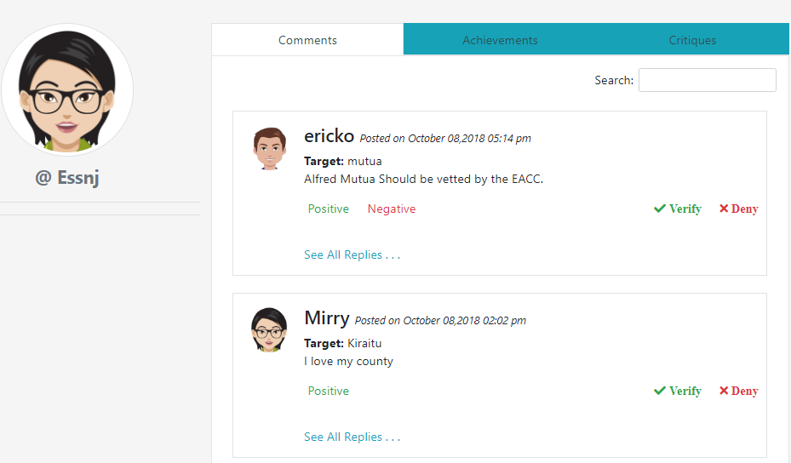

#### Figure 5.1: Verify Posts by other users

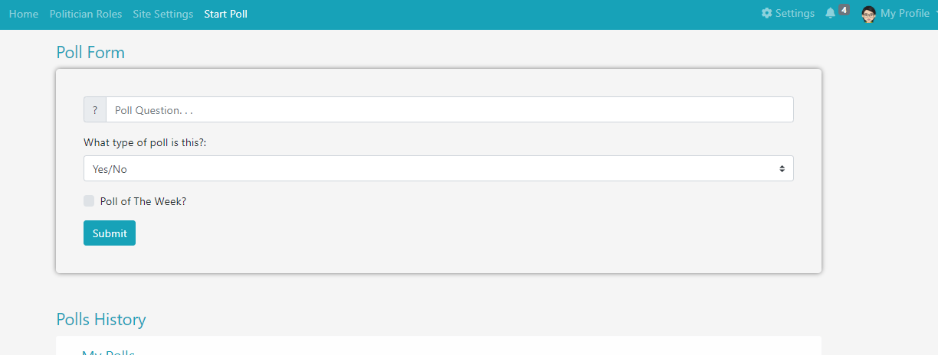

#### Figure 5.2: Post a poll

## 5.3 Politician Module

The politician Module allows the politicians to create accounts and specify their background, personal and political information which is verified by the admin then after it is visible to all the system users. This module also allows politicians to post achievements and critiques about themselves or other politician but not comments to prevent spreading of propaganda. Politicians are allowed to specify their participation in the upcoming elections. The politician can post videos to inform the citizens about their where-about regarding their political functions. Finally, the module allows the politician to post their manifesto or alter their information which also has to be verified.

### 5.3.1 Functionalities

A politician is a major player in the site. All information in the site is relating to a specific politician. All comments, achievements and critiques will have a target which will be the username of a specific politician. A politician gives all his political and educational information and this is visible to all users on his profile page. A politician can start an opinion poll too. A politician can also be able to modify selected information from his account and the information he/she modifies will be subject to verification by the admin. A politician is able to post achievements and critiques of other leaders in his area, or himself, but not comments. A politician is also be subject to rating by the site in terms of popularity and efficiency. A politician can finally be followed by citizens to increase his popularity.

### 5.3.2 Screenshots

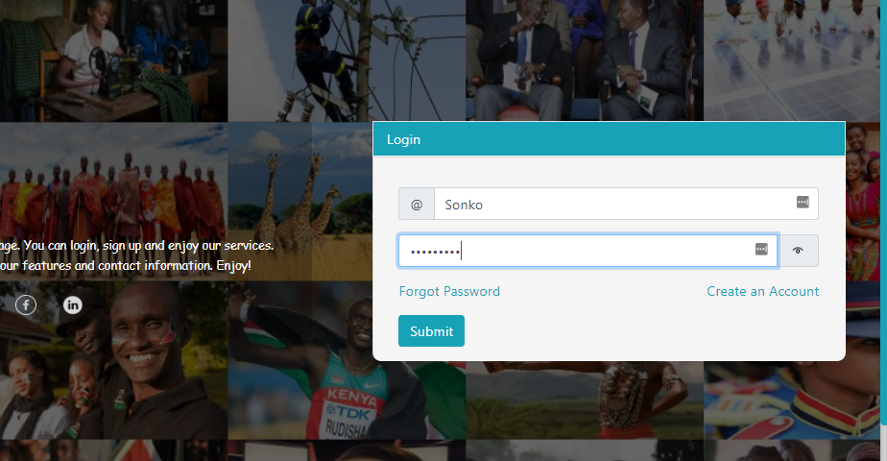

#### Figure 5.3: Log in Form

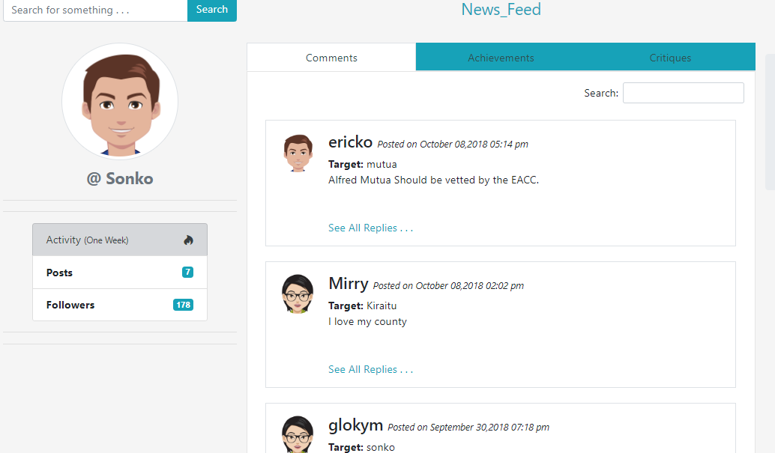

#### Figure 5.4: Politician’s landing page and view comments.

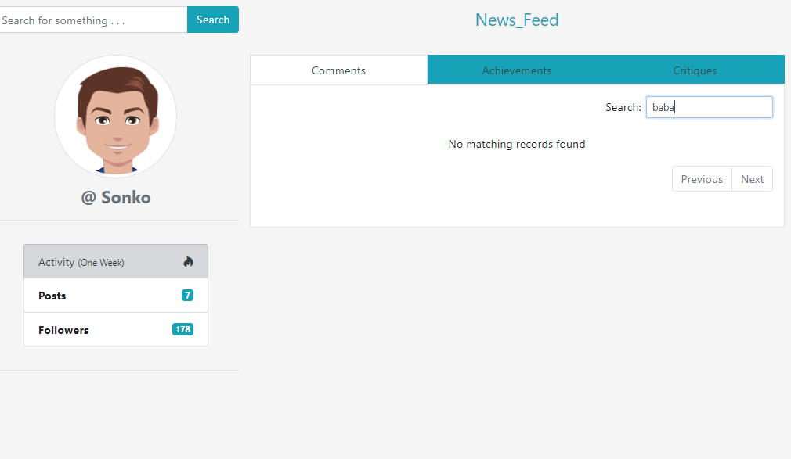

#### Figure 5.5: Search Functionality

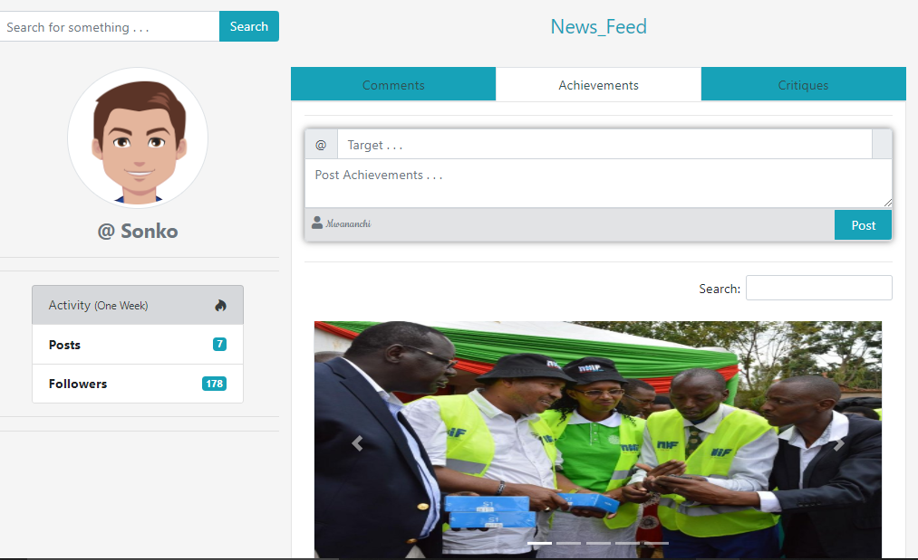

#### Figure 5.6: Post Achievements and Critiques

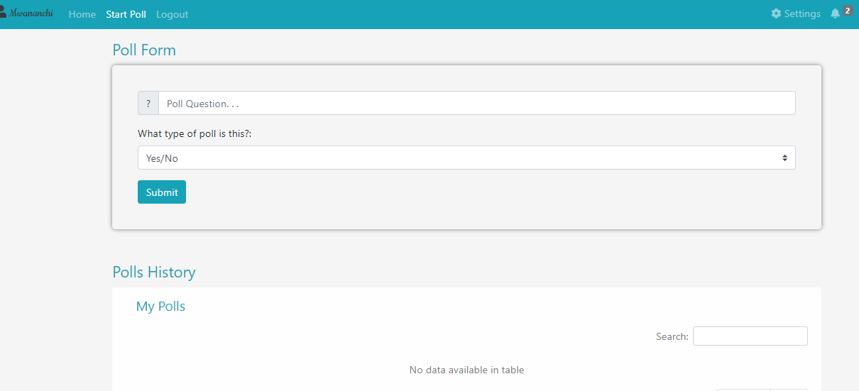

#### Figure 5.7: Politician’s poll view

## 5.4 Citizen Module

The Citizen module allows citizens to create accounts which is a restricted event because a politician cannot create a citizen account. Upon account creation, the admin ensures that it is not a politician disguised as a citizen and also that a citizen does not have more than one account. The citizens can view the politician’s information and post comments about the politician. The citizens are able to post the politician’s achievements and critiques on this module. The citizen can follow a politician, dislike or like a posted comment, share and reply to a post. Information posted by a citizen is verified by the admin.

### 5.4.1 Functionalities

A citizen has the most important role in the site. All politician’s popularity is heavily dependent upon a citizen. Citizens view politician information: background information, political information and educational information. They also have access to politician functions for the various political seats in a county and the manifesto of the politicians. Citizens will be able to post comments, achievements and critiques for leaders in their county. These will be used to gauge the politician’s efficiency and popularity. Finally, a citizen can modify their account information.

### 5.4.2 Screenshots

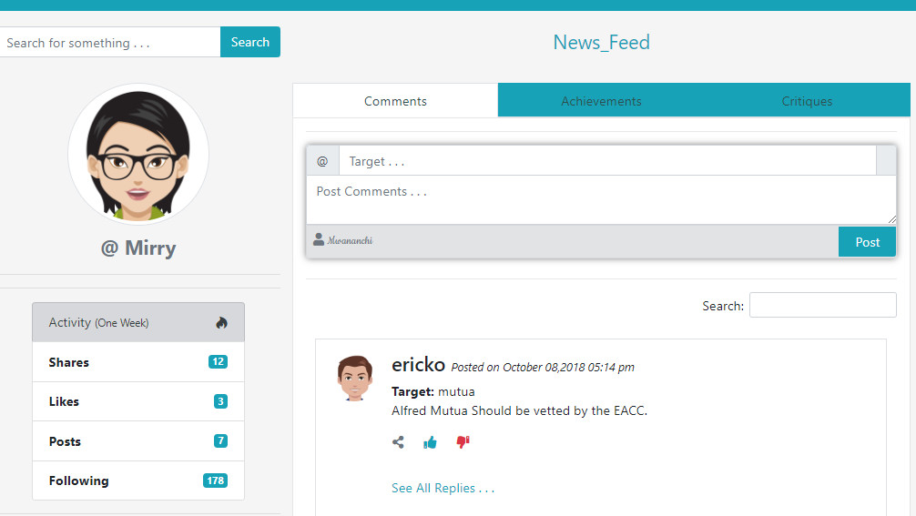

#### Figure 5.8: Post achievements, comments and critiques

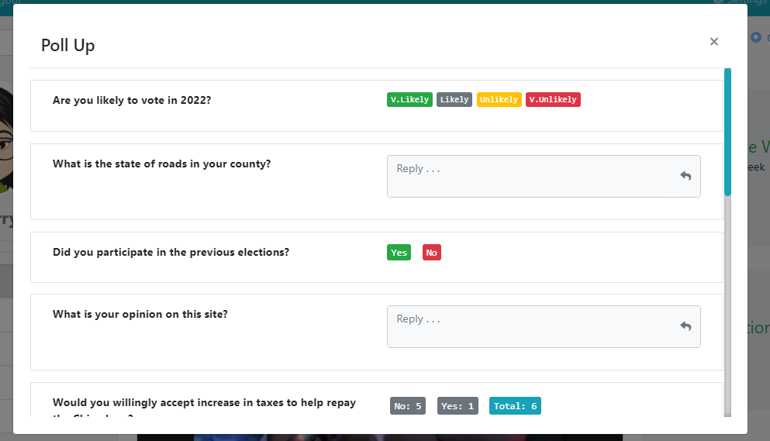

#### Figure 5.9: Participate in polls.

#### 

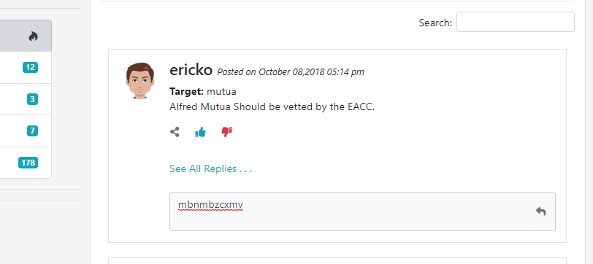

#### Figure 6.0: Reply to comments

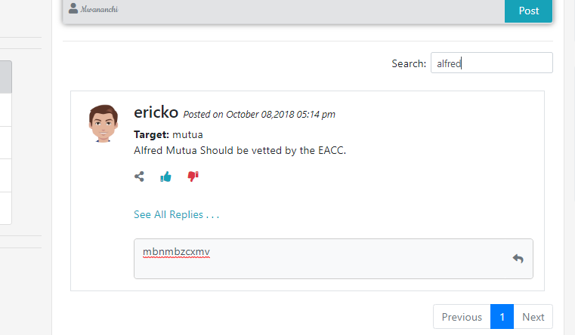

#### Figure 6.1: Search Functionality for citizens

# Chapter 6: Conclusions, Recommendations and Future Works

## 6.1 Introduction

This chapter discusses about the conclusions draw based on the objectives, recommendations given to someone using the system and the future works that may be added to make the system better.

## 6.2 Conclusions

This project investigated Challenges facing citizens during the election process and these some that we came across:

Citizens do not know the political or educational background information of the leaders vying for a political seat. This brings about confusion because the citizens are not sure who to vote for. Citizens find it hard to contact their leaders. Citizens do not have a clue about the leader’s progress in a way they don’t know the leaders’ achievements.

This project reviewed existing solutions that enables citizens of a particular citizens to know about their politicians and post their opinions about the leaders.

This project designed, developed and tested an application that assists the citizens to know their politician and his efficiency in bringing changed to the country.

## 6.3 Recommendations

The system is built on CodeIgniter which is a php framework. This helps the programmer because it structures the code. The system was built using CSS, HTML, BOOTSTRAP and PHP web language.

For user using the system, he or she should have a basic computer knowledge. This eases navigation through the system.

## 6.4 Future Works

Time being one of the major constraints, they system would be more dynamic in a way, there would be more political seats and the scope would be broader such that the system encompasses the 47 counties. The citizen would be able to directly interact with the politician.S

# References

African Politics and Policy Newsletter. (2010). Retrieved August 31, 2018, from http://www.africanpoliticsandpolicy.com/?page_id=10

Cheeseman, N., Lynch, G., & Willis, J. (2016). Decentralisation in Kenya: the governance of governors. *The Journal of Modern African Studies*, *54*(01), 1–35. https://doi.org/10.1017/S0022278X1500097X

Fact-checking U.S. politics. (2005). Retrieved August 31, 2018, from /truth-o-meter/

Functional Requirements vs Non-Functional Requirements. (2012, April 5). Retrieved August 26, 2018, from https://reqtest.com/requirements-blog/functional-vs-non-functional-requirements/

Hope, K. R. (2017). Corruption in Kenya. In S. Hope Kempe Ronald (Ed.), *Corruption and Governance in Africa: Swaziland, Kenya, Nigeria* (pp. 61–123). Cham: Springer International Publishing. https://doi.org/10.1007/978-3-319-50191-8_3

Ismail, J. A., & Deane, J. (2008). The 2007 General Election in Kenya and Its Aftermath: The Role of Local Language Media. *The International Journal of Press/Politics*, *13*(3), 319–327. https://doi.org/10.1177/1940161208319510

*Joho: Look where my D- grade brought me — VIDEO*. (2017). Retrieved from https://www.nation.co.ke/news/Hassan-Joho-woes-KCSE-grade/1056-3867864-rqxbre/index.html

Kramon, E., & Posner, D. N. (2011). Kenya’s New Constitution. *Journal of Democracy*, *22*(2), 89–103. https://doi.org/10.1353/jod.2011.0026

Modelling variability by UML use case diagrams. (2016). Retrieved August 26, 2018, from http://scholar.googleusercontent.com/scholar?q=cache:gafd3pLXkDEJ:scholar.google.com/+use+case+diagram+definition&hl=en&as_sdt=0,5

Naumann, J. D., & Jenkins, A. M. (1982). Prototyping: The New Paradigm for Systems Development. *MIS Quarterly*, *6*(3), 29–44. https://doi.org/10.2307/248654

Polling and Data Analytics. (2016, August 1). Retrieved August 31, 2018, from https://icitizen.com/how-it-works/

Rossi, B. (2007). Entity Relationship Diagram, 16.

Shafer, L., Press, Y., Scott, V., & Bieman, J. M. (1996). McConnell, Steve. Rapid Development. Redmond WA: Microsoft Press. 1996., 2.

Software Development Methodologies. (2016). Retrieved August 26, 2018, from http://www.itinfo.am/eng/software-development-methodologies/

System Design and Development. (2013). *The MITRE Corporation*. Retrieved from https://www.mitre.org/publications/systems-engineering-guide/se-lifecycle-building-blocks/system-design-and-development

Tao, Y., & Kung, C. (1991). Formal definition and verification of data flow diagrams. *Journal of Systems and Software*, *16*(1), 29–36. https://doi.org/10.1016/0164-1212(91)90029-6

tutorialspoint.com. (n.d.-a). DBMS Data Schemas. Retrieved August 27, 2018, from https://www.tutorialspoint.com/dbms/dbms_data_schemas.htm

tutorialspoint.com. (n.d.-b). System Analysis and Design Overview. Retrieved August 26, 2018, from https://www.tutorialspoint.com/system_analysis_and_design/system_analysis_and_design_overview.htm

What is a Database Schema? (2016, May 9). Retrieved August 27, 2018, from https://www.lucidchart.com/pages/database-diagram/database-schema

# Appendix

## Appendix A: Gantt Chart

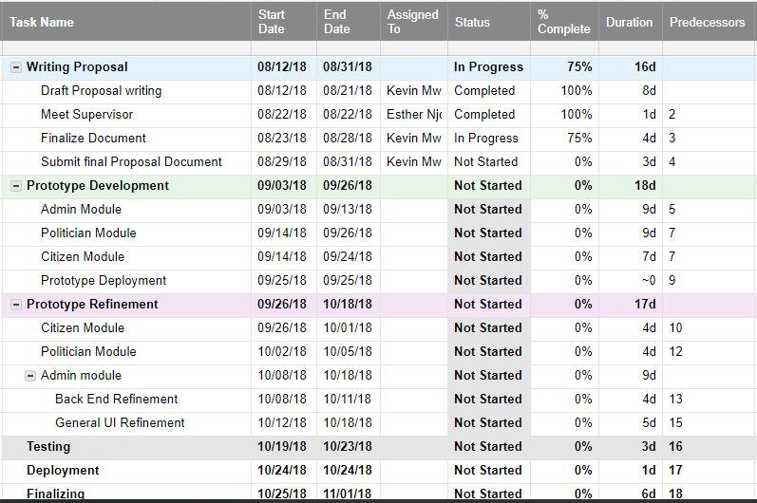

#### Figure 5.1: Gantt Chart Table

#### Figure 5.2: Gantt Chart Diagram.